Chapter 14, Solution 12.

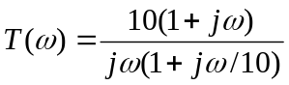

To sketch this we need 20log₁₀ |T(ω)| = 20log₁₀ |10| + 20log₁₀ |1+jω| – 20log₁₀ |jω| – 20log₁₀ |1+jω/10| and the phase is equal to tan^{–1}(ω) – 90° – tan^{–1}(ω/10).

The plots are shown below.

|T| (db)

20

0
0.1 1 10 100

-20

-40

arg T

90º

0
0.1 1 10 100

-90º

